Tail dependence: EURUSD and USDJPY
Method 19 / daily log returns / alpha=0.05 / Alpari D1 full available history

Study setup
Logical pair: EURUSD , USDJPY
Broker symbols: EURUSD_i , USDJPY_i
Snapshot: 2026-11-03_majors_alpari_D1
Timeframe: D1
Matched return window: 1999-01-05 to 2026-11-02 (UTC bar dates)
Matched return count n: 7200
Dropped unfinished last bar dated 2026-11-03 UTC after a tick-volume check against the prior complete day.
Uniforms: ranks/(n+1); alpha=0.05
Complete matched rows (Excel): EURUSD-USDJPY_Tail_D1.xlsx
Complete matched rows (HTML table): EURUSD-USDJPY_Tail_D1_data.html

Method carried forward
Tail dependence counts how often both legs sit in an extreme uniform tail together. Matched daily log returns of close, ln(close_t / close_t-1), become u_i = rank(x_i)/(n+1) and v_i = rank(y_i)/(n+1). At alpha=0.05, lower L_hat = (# u<=alpha and v<=alpha) / (# conditioning leg <= alpha); upper uses >= 1-alpha. Both conditioning directions are reported with numerator and denominator counts. Quotes are not inverted. L_hat(0.05) is a finite-sample frequency, not the asymptotic lambda. Same-sample Pearson r is a side check. This is not causation and not a trading signal.

Results
tail | cond | L_hat | num | denom
lower | USDJPY | 0.063889 | 23 | 360
lower | EURUSD | 0.063889 | 23 | 360
upper | USDJPY | 0.047222 | 17 | 360
upper | EURUSD | 0.047222 | 17 | 360
Pearson r on returns: -0.300952

Conclusion
Over 7200 matched daily rows for EURUSD and USDJPY at alpha=0.05, lower L_hat conditioning on USDJPY is 0.0639 (23/360); conditioning on EURUSD is 0.0639. Upper L_hat conditioning on USDJPY is 0.0472; on EURUSD is 0.0472. Pearson r = -0.3010. These are finite-sample frequencies, not asymptotic lambda and not a trading signal.

Charts
Daily closes

Daily log returns

Uniforms with alpha lines
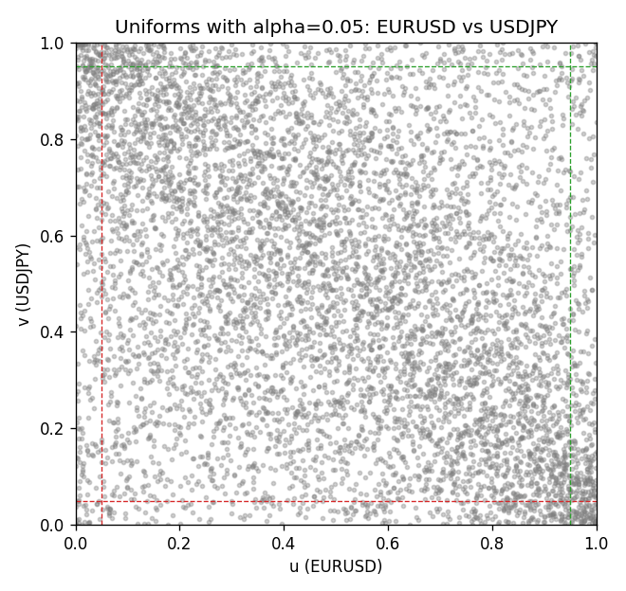

Data report
Every matched row is stored in the sibling Excel workbook named EURUSD-USDJPY_Tail_D1.xlsx, including u and v. Embedding all rows as a Word table is impractical; this file holds column summaries and the first and last 15 matched rows.
Columns: time, EURUSD_open, USDJPY_open, EURUSD_high, USDJPY_high, EURUSD_low, USDJPY_low, EURUSD_close, USDJPY_close, EURUSD_tick_volume, USDJPY_tick_volume, EURUSD_spread, USDJPY_spread, EURUSD_real_volume, USDJPY_real_volume, EURUSD_log_return, USDJPY_log_return, u, v
Column summaries (matched calculation rows)
column | count | mean | std | min | 25% | 50% | 75% | max
EURUSD_open | 7200 | 1.1812699 | 0.15089907 | 0.8272 | 1.086045 | 1.16609 | 1.2939325 | 1.5995
USDJPY_open | 7200 | 113.80877 | 19.206548 | 75.693 | 104.4225 | 110.983 | 120.69125 | 163.824
EURUSD_high | 7200 | 1.1864006 | 0.15149686 | 0.8326 | 1.0901575 | 1.17121 | 1.2991625 | 1.6038
USDJPY_high | 7200 | 114.3063 | 19.268128 | 76.001 | 104.878 | 111.441 | 121.26 | 163.978
EURUSD_low | 7200 | 1.1762568 | 0.15022122 | 0.8227 | 1.0819775 | 1.162475 | 1.288265 | 1.5865
USDJPY_low | 7200 | 113.28572 | 19.134551 | 75.402 | 103.8875 | 110.53 | 120.17 | 163.628
EURUSD_close | 7200 | 1.1813075 | 0.15087411 | 0.8267 | 1.085995 | 1.16602 | 1.2939425 | 1.5997
USDJPY_close | 7200 | 113.82186 | 19.221964 | 75.811 | 104.4165 | 111.023 | 120.6855 | 163.851
EURUSD_tick_volume | 7200 | 103020.56 | 173417.03 | 218 | 9398.5 | 52714 | 99443.25 | 1471626
USDJPY_tick_volume | 7200 | 106139.77 | 179306.98 | 149 | 9927.5 | 53095 | 92761 | 1803508
EURUSD_spread | 7200 | 19.389444 | 16.57873 | 0 | 8 | 12 | 30 | 50
USDJPY_spread | 7200 | 20.3175 | 17.636173 | 0 | 6 | 11 | 30 | 50
EURUSD_real_volume | 7200 | 4.0252061e+10 | 1.6676396e+11 | 0 | 0 | 0 | 0 | 3.6149665e+12
USDJPY_real_volume | 7200 | 3.4708591e+10 | 1.6077621e+11 | 0 | 0 | 0 | 0 | 3.8834203e+12
EURUSD_log_return | 7200 | -1.012e-05 | 0.00580063 | -0.03123819 | -0.0032472 | 0 | 0.00325137 | 0.03433183
USDJPY_log_return | 7200 | 4.989e-05 | 0.00620383 | -0.03908203 | -0.00319719 | 0.00011638 | 0.00340925 | 0.05184024
u | 7200 | 0.5 | 0.28865509 | 0.00013887 | 0.25006943 | 0.49965283 | 0.74993057 | 0.99986113
v | 7200 | 0.5 | 0.28865508 | 0.00013887 | 0.25006943 | 0.5 | 0.74993057 | 0.99986113
First 15 matched rows (selected columns)
time | EURUSD_log_return | USDJPY_log_return | u | v
1999-01-05 | -0.0048360507 | -0.00017868311 | 0.16928204 | 0.47118456
1999-01-06 | -0.011547966 | 0.0075660159 | 0.028190529 | 0.91167893
1999-01-07 | 0.0076280636 | -0.012851583 | 0.91931676 | 0.023191223
1999-01-08 | -0.010902799 | -0.0047719894 | 0.032634356 | 0.16830996
1999-01-11 | -0.007103287 | -0.016195423 | 0.096236634 | 0.013331482
1999-01-12 | 0.0045103728 | 0.032310364 | 0.81974726 | 0.99958339
1999-01-13 | 0.010845346 | 0.0081373171 | 0.96653243 | 0.92501042
1999-01-14 | 0 | 0 | 0.49965283 | 0.48736287
1999-01-15 | -0.010153245 | 0.0055343401 | 0.039994445 | 0.85168727
1999-01-18 | 0.0036256946 | 8.7600193e-05 | 0.77503125 | 0.49729204
1999-01-19 | -0.00017235436 | -0.0056219403 | 0.48451604 | 0.13928621
1999-01-20 | -0.0031939256 | -0.0053879917 | 0.25371476 | 0.14636856
1999-01-21 | 0.0030215416 | 0.0084664056 | 0.73614776 | 0.92959311
1999-01-22 | -0.0012075213 | 0.0060412564 | 0.39341758 | 0.86932371
1999-01-25 | -0.0030251979 | -0.0073594164 | 0.26343563 | 0.092209415
Last 15 matched rows (selected columns)
time | EURUSD_log_return | USDJPY_log_return | u | v
2026-10-13 | 0.0037402957 | -0.0018932826 | 0.7821136 | 0.32787113
2026-10-14 | -0.0037582255 | 7.5800166e-05 | 0.22427441 | 0.49548674
2026-10-15 | 0.0056053107 | -0.0018524319 | 0.8661297 | 0.33078739
2026-10-16 | 0.0017724895 | -0.00037976126 | 0.6500486 | 0.45007638
2026-10-19 | -0.0025394633 | 0.0034946841 | 0.2964866 | 0.75489515
2026-10-20 | 0.0023881672 | -0.0022546642 | 0.69365366 | 0.30384669
2026-10-21 | -0.00032046717 | -0.00032883504 | 0.47160117 | 0.45604777
2026-10-22 | -0.0015949606 | -0.0085942669 | 0.36397723 | 0.066796278
2026-10-23 | -0.001338521 | 0.00035080446 | 0.38300236 | 0.52173309
2026-10-26 | -0.0022706559 | 0.0041238746 | 0.31342869 | 0.79155673
2026-10-27 | -0.004152342 | 0.0027651658 | 0.20108318 | 0.71156784
2026-10-28 | 0.0022262927 | -0.00095679538 | 0.68351618 | 0.39827802
2026-10-29 | 0.0022571351 | -0.00038043789 | 0.6861547 | 0.44993751
2026-10-30 | -0.0011458446 | -0.0010596481 | 0.39869463 | 0.39175115
2026-11-02 | 0.002120569 | 0.0026438521 | 0.67712818 | 0.70337453

